Module Name: OrangeHRM
Test Case ID: SD_TC_003
Scenario ID: 1a
Scenario: Login with valid information
Test Steps:
1. Open OrangeHRM.
2. Enter valid username and password.
3. Click Login.
Test Input: Valid username and password
Expected Result: User should log in and the dashboard should appear.
Actual Result: Dashboard appeared successfully.
Status: Pass*
Screenshot:
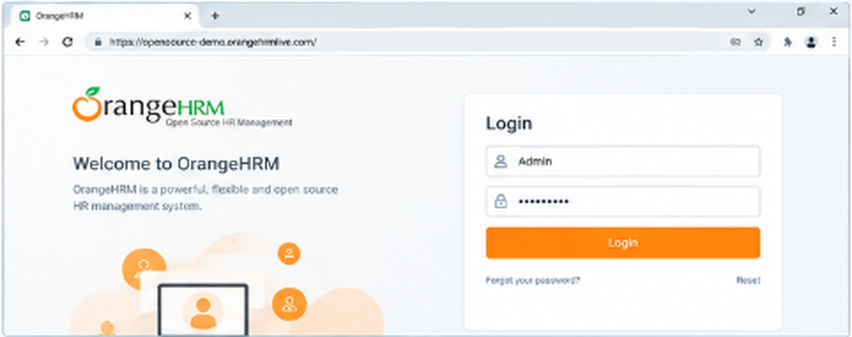

Scenario ID: 1b
Scenario: Open PIM section
Test Steps:
1. Log in.
2. Click PIM from the menu.
Test Input: PIM menu
Expected Result: PIM page should open successfully.
Actual Result: PIM page opened successfully.
Status: Pass*
Screenshot:
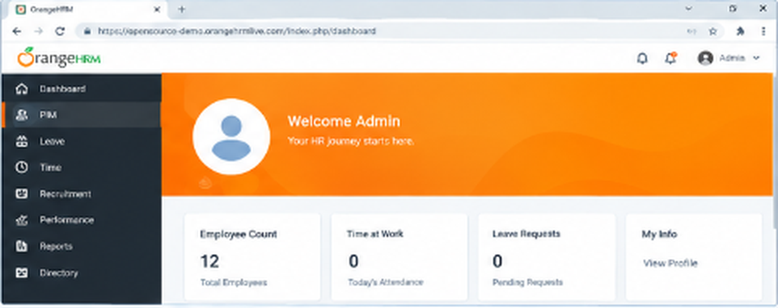

Scenario ID: 1c
Scenario: Add a new employee
Test Steps:
1. Open PIM.
2. Click Add Employee.
3. Enter first name and last name.
4. Click Save.
Test Input: First name: Rahul; Last name: Patel
Expected Result: Employee should be saved and the employee profile should appear.
Actual Result: Employee profile appeared after saving.
Status: Pass*
Screenshot:
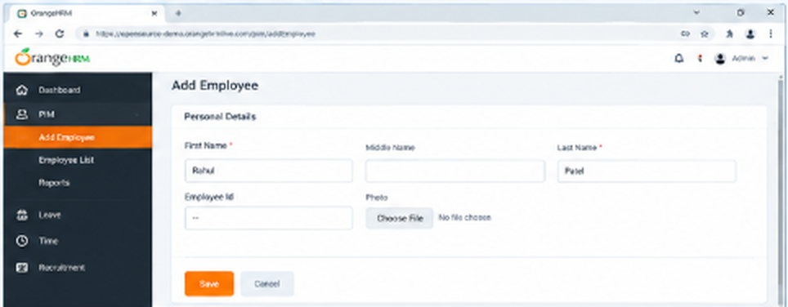

Scenario ID: 1d
Scenario: Search employee
Test Steps:
1. Open Employee List.
2. Enter the employee name.
3. Click Search.
Test Input: Rahul Patel
Expected Result: The added employee should appear in the search results.
Actual Result: Employee appeared in search results.
Status: Pass*
Screenshot:
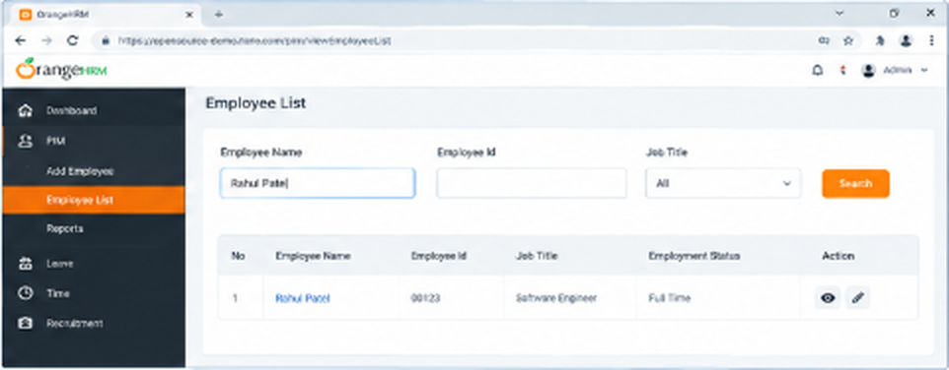

Scenario ID: 1e
Scenario: Verify employee details
Test Steps:
1. Open the employee record.
2. Check the name and employee details.
Test Input: Rahul Patel
Expected Result: Displayed details should match the saved information.
Actual Result: Details matched the saved information.
Status: Pass*
Screenshot:
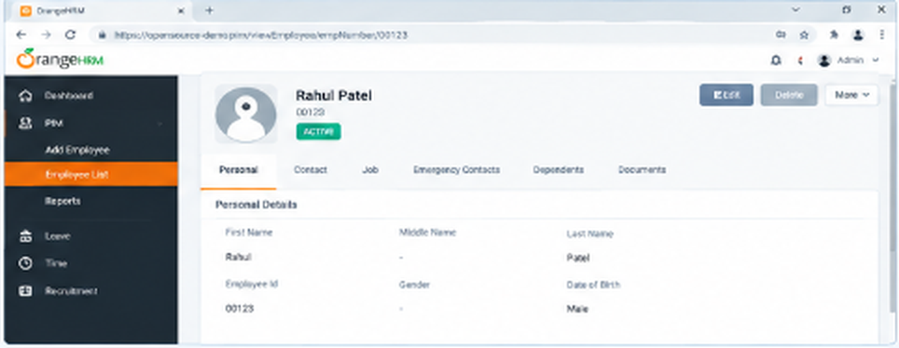

Scenario ID: 1f
Scenario: Edit employee details
Test Steps:
1. Open the employee record.
2. Edit an editable field.
3. Click Save.
Test Input: Updated employee information
Expected Result: Updated information should be saved successfully.
Actual Result: Updated information was displayed.
Status: Pass*
Screenshot:
